**Image Classification using ResNet50 Convolutional Neural Network (CNN)**

**Objective:**  
Train and evaluate a ResNet50 transfer-learning model on the fungal microscopy dataset, using a frozen→fine-tune schedule.

**1. Introduction**

ResNet50 is a 50-layer CNN that uses skip connections (residual links) to train deep networks reliably. We adopt transfer learning: reuse ImageNet-pretrained convolutional features, attach a task-specific head, train the head first, then lightly fine-tune the top residual block at a small learning rate. This setup usually improves generalization and stability on limited datasets.

**2. Dataset**

* Source: [Microscopic Fungi Image - DeFungi Dataset | Kaggle](https://www.kaggle.com/datasets/anshtanwar/microscopic-fungi-images)
* Classes: 5
* H1: Candida albicans  
    
  H2: Aspergillus niger  
    
  H3: Trichophyton rubrum  
    
  H5: Trichophyton mentagrophytes  
    
  H6: Epidermophyton floccosumTotal images: [Number]
* Preprocessing:
* Resized images to 224×224 pixels
* Normalized pixel values to range [0, 1]
* Applied data augmentation

**3. Methodology**

* **Model:** **Backbone:** ResNet50(weights="imagenet", include_top=False); **frozen** during head training.
* **Head:** GlobalAveragePooling2D → Dropout → Dense(512, ReLU, L2) → Dropout → Dense(num_classes, Softmax, L2)
* **Loss:** Categorical Cross-Entropy with label smoothing = 0.1 (reduces over-confidence)
* **Optimizer**: Adam.
* **Head training LR: 1e-3**
* **Fine-tuning LR: 1e-5**
* **Batch size:** 32
* **Epochs:** 40
* **Training schedule**
* **Phase A —** Train head (frozen backbone): EPOCHS_HEAD = 12.
* **Phase B —** Fine-tune top residual stage: unfreeze conv5_* layers only; train for EPOCHS_FT = 28 more (total = 40).

**4. Results**

* **Training Accuracy & Validation Accuracy –**
* **Test Accuracy** – 82.48 %
* **Macro F1 –** 85.66%
* **ROC AUC -** 0.969
* 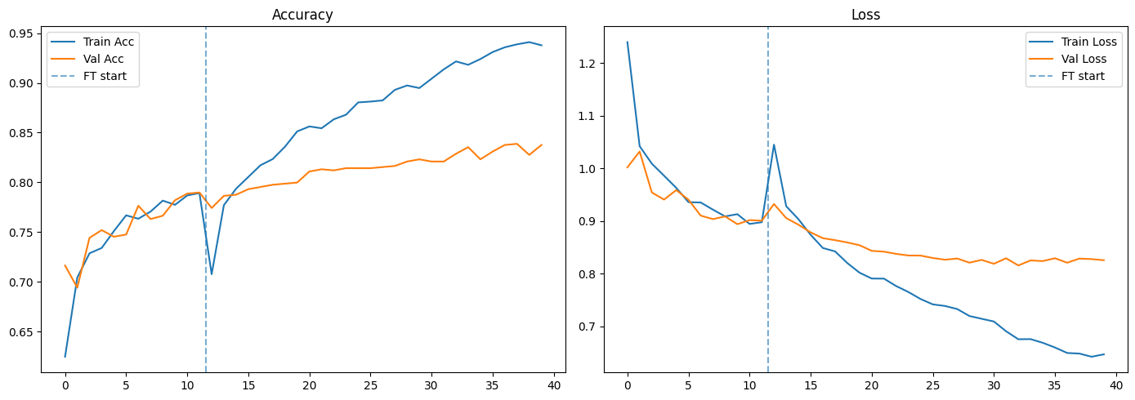
* **Confusion Matrix:** Shows predictions per class
* 